Difference between abstract class and interface

Abstract class and interface both are used to achieve abstraction where we can declare the abstract methods. Abstract class and interface both can't be instantiated.

But there are many differences between abstract class and interface that are given below.

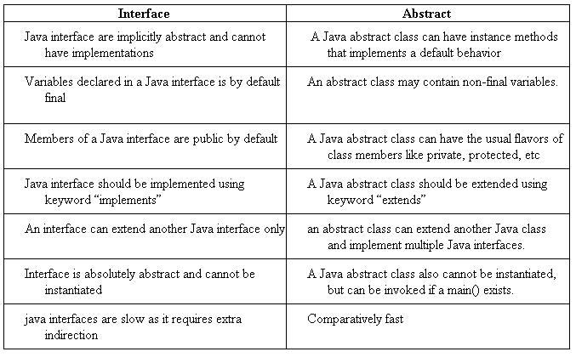

|  |  |
| --- | --- |
| **Abstract class** | **Interface** |
| 1) Abstract class can **have abstract and non-abstract**methods. | Interface can have **only abstract** methods.  Since Java 8, it can have **default and**  **static methods** also. |
| 2) Abstract class **doesn't support multiple inheritance**. | Interface **supports multiple inheritance**. |
| 3) Abstract class **can have final, non-final, static and non-static variables**. | Interface has **only static and final variables**. |
| 4) Abstract class **can provide the implementation of interface**. | Interface **can't provide the implementation**  **of abstract class**. |
| 5) The **abstract keyword** is used to declare abstract class. | The **interface keyword** is used to declare interface. |
| 6) An **abstract class** can extend another Java class and implement multiple Java interfaces. | An **interface** can extend another Java interface only. |
| 7) An **abstract class** can be extended using keyword "extends". | An **interface** can be implemented using  keyword "implements". |
| 8) A Java **abstract class** can have class members like private, protected, etc. | Members of a Java interface are public by default. |
| 9)**Example:** public abstract class Shape{ public abstract void draw(); } | **Example:** public interface Drawable{ void draw(); } |

Simply, abstract class achieves partial abstraction (0 to 100%) whereas interface achieves fully abstraction (100%).

Example of abstract class and interface in Java

Let's see a simple example where we are using interface and abstract class both.

1. //Creating interface that has 4 methods
2. **interface** A{
3. **void** a();//bydefault, public and abstract
4. **void** b();
5. **void** c();
6. **void** d();
7. }
9. //Creating abstract class that provides the implementation of one method of A interface
10. **abstract** **class** B **implements** A{
11. **public** **void** c(){System.out.println("I am C");}
12. }
14. //Creating subclass of abstract class, now we need to provide the implementation of rest of the methods
15. **class** M **extends** B{
16. **public** **void** a(){System.out.println("I am a");}
17. **public** **void** b(){System.out.println("I am b");}
18. **public** **void** d(){System.out.println("I am d");}
19. }
21. //Creating a test class that calls the methods of A interface
22. **class** Test5{
23. **public** **static** **void** main(String args[]){
24. A a=**new** M();
25. a.a();
26. a.b();
27. a.c();
28. a.d();
29. }}